shefali DK

SnagIT  
Screen Capturing Tool

Version 19.1.11

**List of Figures**

Figure 1: Full Screen Capture 1

Figure 2: Window capture 1

Figure 3: Horizontal Panoramic capture 2

Figure 4: Horizontal & Vertical Panoramic Capture 2

Figure 5: Scrolling capture 3

Figure 6: Delay Capture 4

Figure 7: Interval capture 4

Figure 8: Scheduled capture 5

Figure 9: Video Capture 5

# Image Captures

Figure 1: Full Screen Capture

Figure 3: Region capture

Figure 2: Window capture

Figure 1: Fullscreen capture

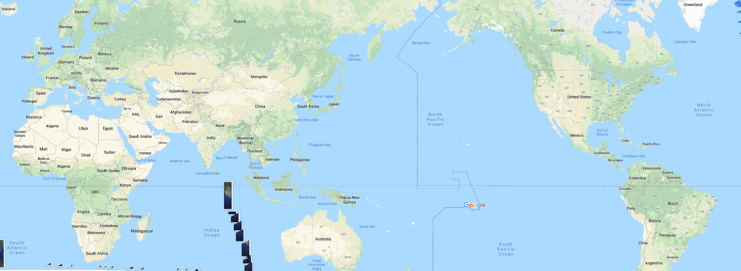

Figure 3: Horizontal Panoramic capture

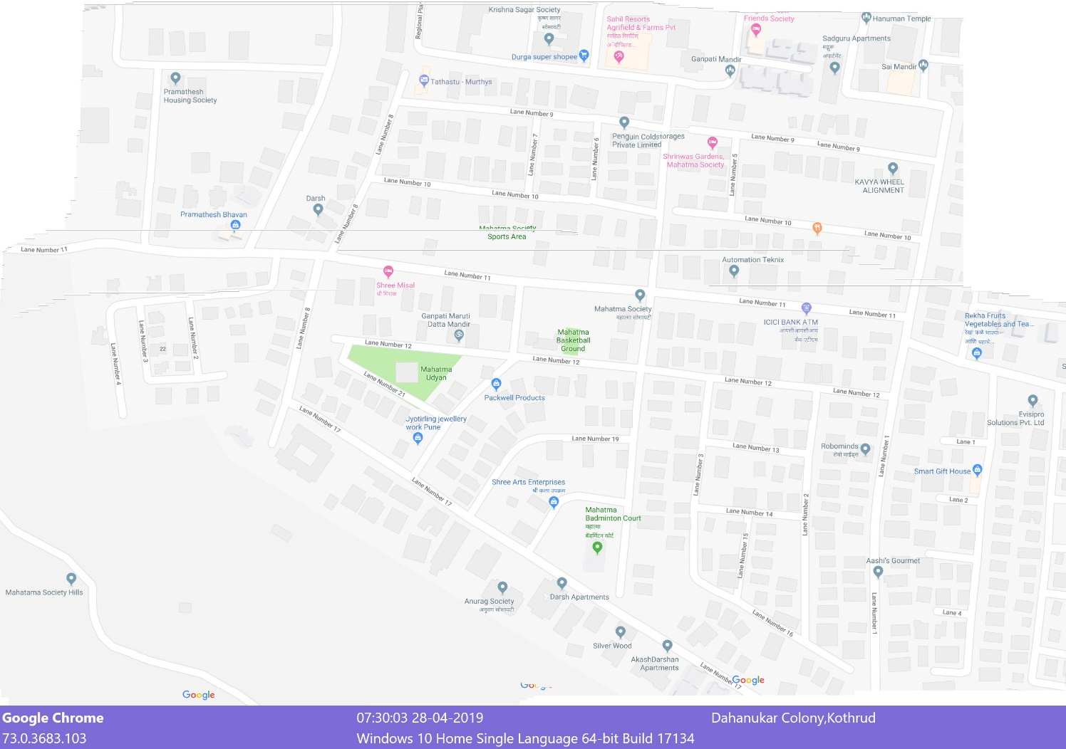

Figure 4: Horizontal & Vertical Panoramic Capture



Figure 5: Scrolling capture

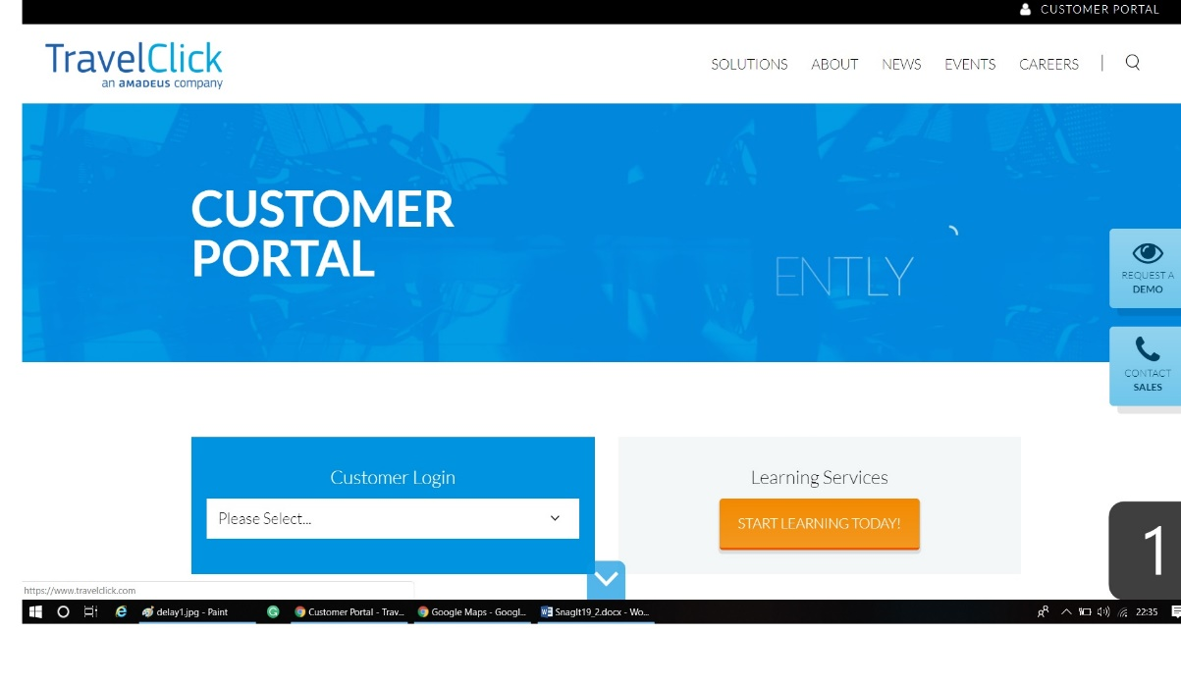

Figure 6: Delay Capture

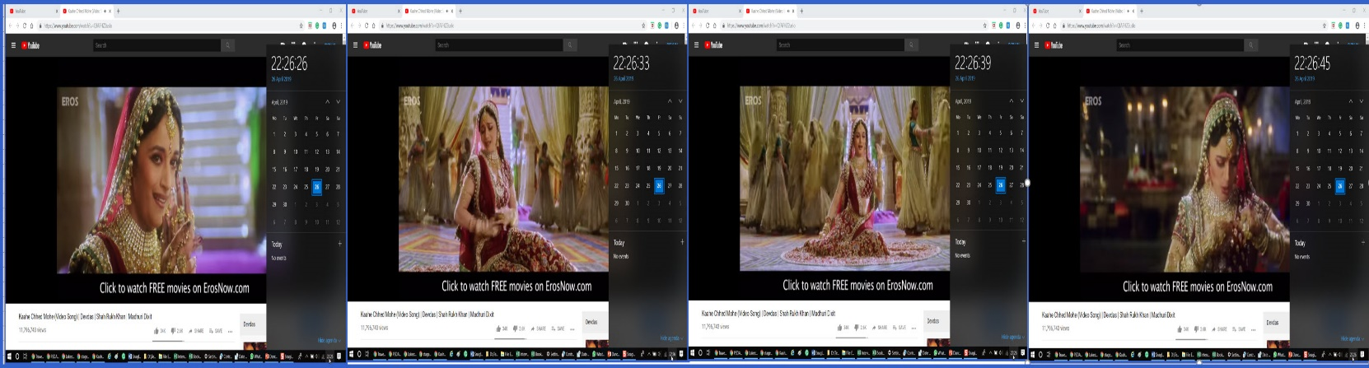

Figure 7: Interval capture

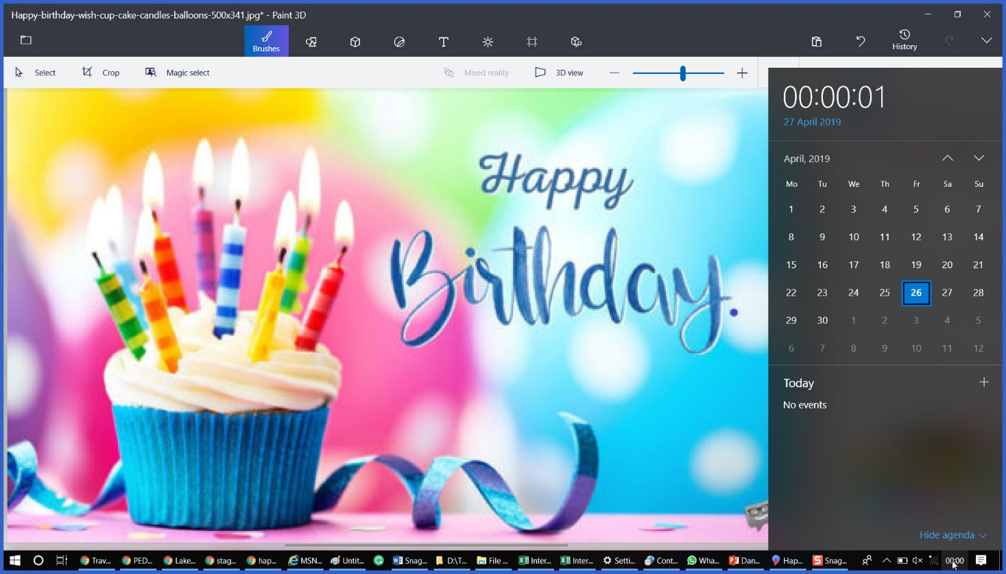

Figure 8: Scheduled capture

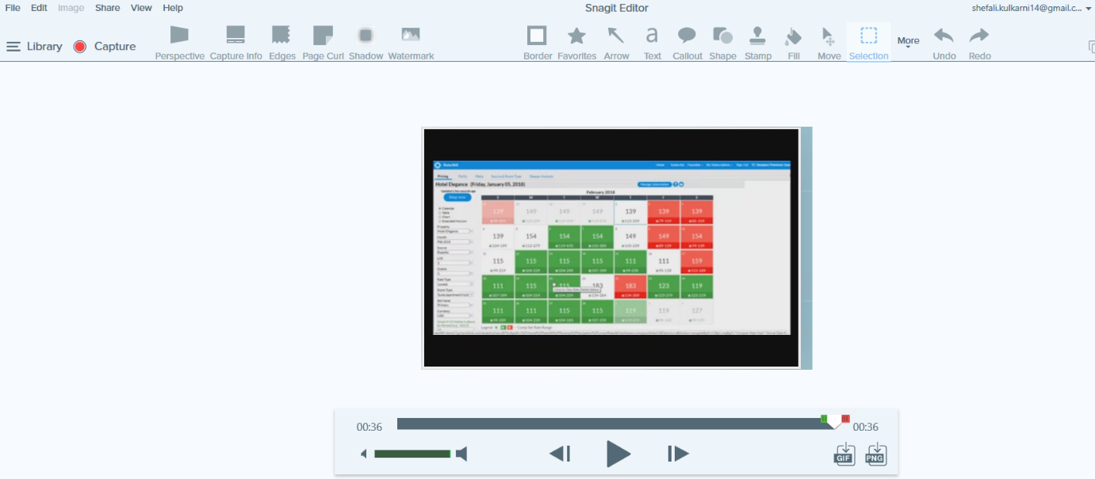

Figure 9: Video Capture

# View Image

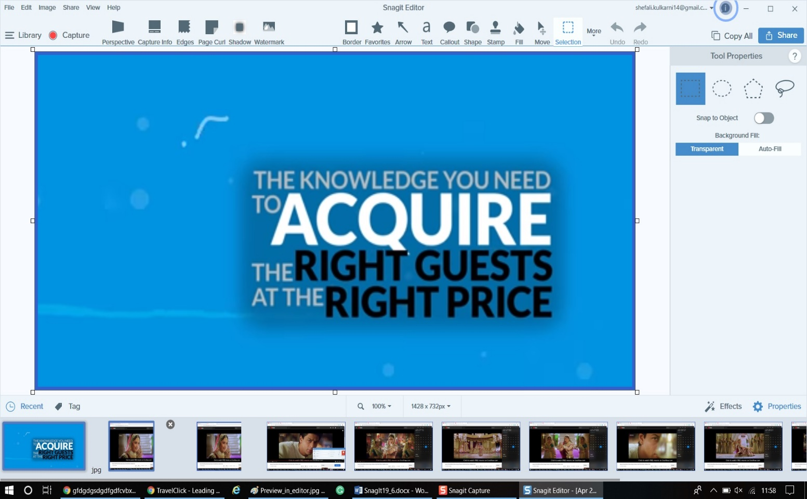

Figure 11: Preview in Editor

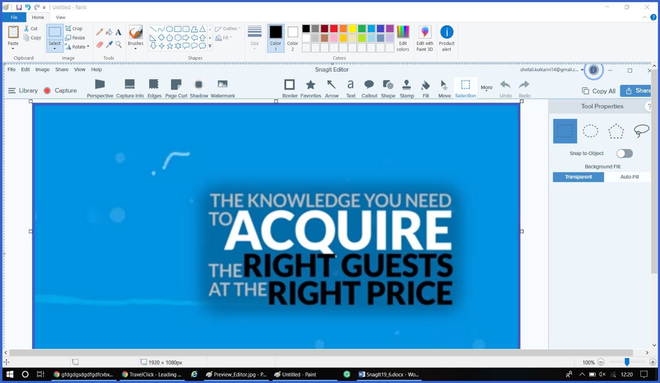

Figure 12: Copy to clipboard

# Add effects:

Figure 13: Border Effect

Figure 14: Capture Info

# 

Figure 15: Watermark

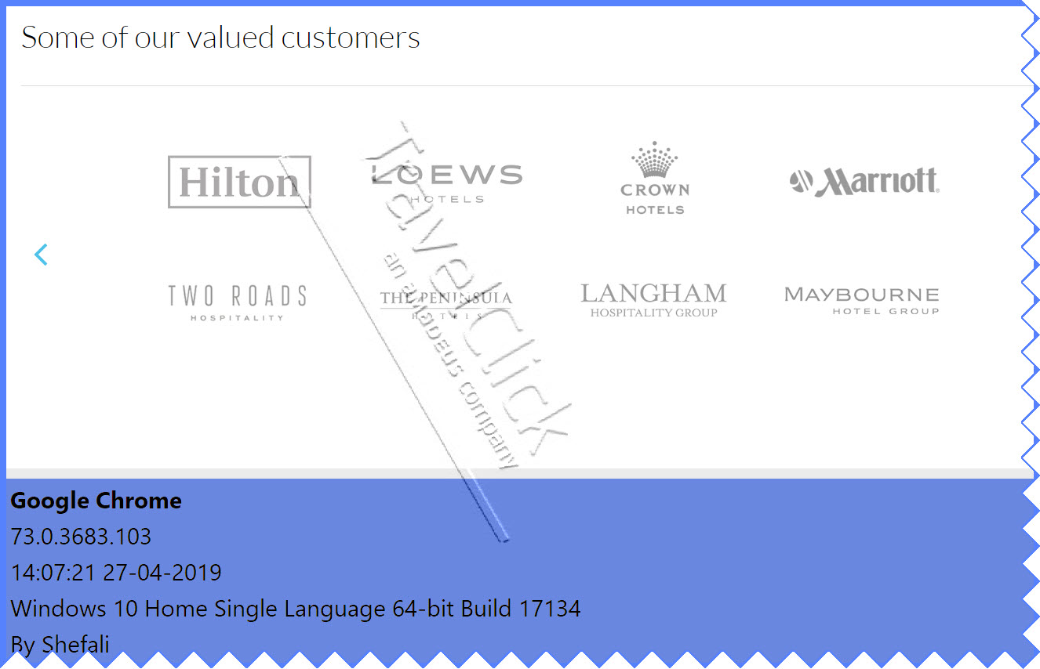

Figure 16: Multiple Effects

# Capture Text

Figure 17: Grab text

# Save Capture Settings(Presets)

Figure 18: Preset1: Image_with_Border_Watermark_&_Info

# Share Images:

Figure 19: Share image on Sreencast.com

# Set Short-Cut(Hot) Key

Figure 20: Set Short-Cut Key

Figure 9: Crop Image